UCZYMY SIĘ NA J. ANGIELSKIM
MIESIĄC WRZESIEŃ
Colours:
red, orange, yellow, green, blue, purple, pink;

Parts of body:
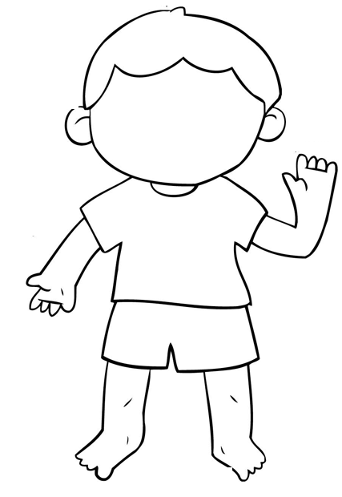
head, shoulders, knees, toes,
arms, hands, hair, fingers

Parts of face:
nose, ears, mouth, eyes,
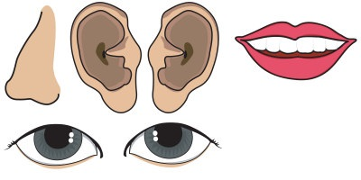
In my classroom:
1-one, 2- two, 3- three,
4-four, 5-five, 6-six, 7-seven,
8-eight, 9-nine, 10-ten.
Family:
mummy, daddy, sister, brother, baby,

